YR 9 CAT 3- RADIOACTIVITY TEST- ANSWERS
Section A - Multiple Choice (10 marks)
- A - made of protons and neutrons
- B - a helium nucleus
- B - periods
- B - beta radiation
- B - It has an atomic number of 20 and a mass of 40.08
- B. Rocks
- C - an electron
- B - the decay is random
- B. beta
- D. 8 days

Section B – Matching Terms (5 marks)
- 2 - Radioactive decay: conversion of a radioactive isotope into its stable form
- 4 - Gamma rays: high-energy electromagnetic rays
- 5 - Alpha particle: a particle containing two protons and two neutrons
- 3 - Beta particle: high-speed electron
- 1 - Beta decay: a neutron is converted into a proton

Section C – Short Answer Questions (25 marks)- ANSWERS IN YELLOW

Question 1
The two isotopes of carbon are shown below.
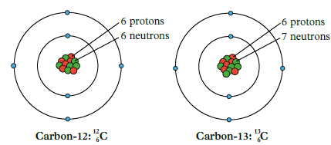

- What are isotopes? (2 marks)

ANSWER:
Atoms of the same element with the same number of protons but different numbers of neutrons. (2 marks)

- Using the information from the figure above, draw an isotope of carbon-14. (2 marks)
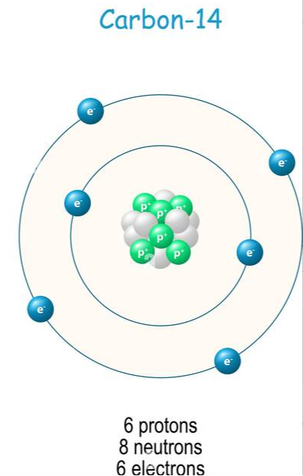

- Explain using the example of Carbon-12, how the ‘Atomic number’ is different from an ‘Atomic mass’?
(2 marks)
ANSWER:

Atomic number is the number of protons, while atomic mass is the sum of protons and neutrons in the nucleus. (2 marks)

- Explain why Carbon-12 atoms are more stable than Carbon-14 atoms. (2 marks)

ANSWER:
Carbon-12 is more stable because it has a balanced proton-to-neutron ratio, unlike Carbon-14, which has excess neutrons, making it unstable. (2 marks)

e. Carbon-14 atoms are unstable; emitting beta particles as they decay. Write an equation to show this decay. (2 marks)
ANSWER:

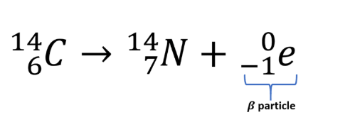
Question 2
Complete nuclear reactions (2 marks)
1. | 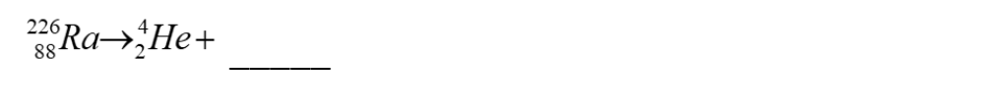
2.

Question 3
Uranium-238 decays in a series of steps into Lead-206, Uranium-238 has a half-life of 4.5 billion years. The graph below shows the decay of Uranium-238 into Lead-206.
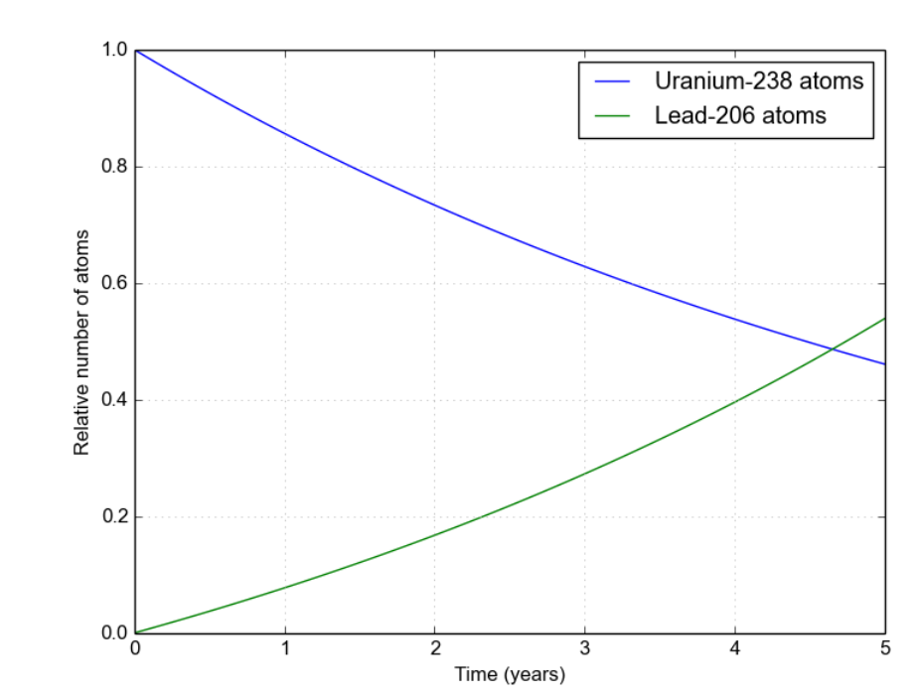
Referencing the graph, explain what is happening to the number of Lead-206 atoms over time.
ANSWER:

- As Uranium-238 decays, Lead-206 increases because Uranium-238 transforms into Lead-206 through decay. Over time, Lead-206 atoms accumulate as Uranium-238 reduces. (2 marks)

Question 4
A Geiger counter is placed near a radioactive source. Different materials are placed between the radioactive source and the Geiger counter. The results of the tests are shown in the table below.
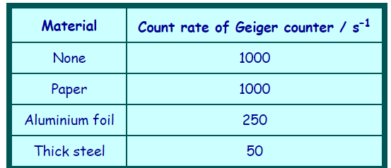
Using the results from the table, identify the 2 types of radiation the radioactive source emits. Explain how you know this. (4 marks)
ANSWER:
Radiation Types are Beta Radiation & Gamma Radiation- 1 Mark for correctly identifying each radiation type (0.5 marks each)
Evidence/ Explanation ( 3 marks)
- Paper has no effect on the count rate, which rules out alpha radiation (as alpha particles are stopped by paper)- 1 mark for explanation on why it cannot be alpha
- The count rate drops significantly when aluminium foil is placed (from 1000 to 250 counts/s), indicating that aluminium blocks beta particles effectively. The significant reduction with aluminium foil suggests beta radiation, as beta particles are stopped by denser materials like aluminium- 1 mark
- The count rate does not drop to zero even with thick steel, indicating the presence of gamma rays, which are highly penetrating and can pass through thick barriers like steel, though with reduced intensity (down to 50 counts/s).- 1mark

HALF LIFE QUESTION- Question 5
Protactinium has a half-life of 70 seconds. A sample of protactinium is prepared and monitored over a period of time. Calculate how many seconds it would take for the sample to drop to 25% of its original weight? (2 marks)
ANSWER:
Half-life = 70 seconds.
After two half-lives (140 seconds/ 2 minutes 20 seconds), 25% of the sample remains. (2 marks)

Question 6
A radioactive decay curve for strontium-90 is shown below.
What is the half-life of Strontium-90 from the graph. Provide evidence on the graph. (2 marks)
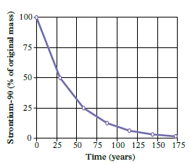

ANSWER:
From the graph, the time for the sample to halve in mass (50%) is the half-life- this is approximately 30 years, depending on graph data- 1 mark
- Evidence: Show interval used for measurement/ mark on the graph(1 mark)
Question 7
The following graph shows the decay for Uranium-238 through to Uranium-234.
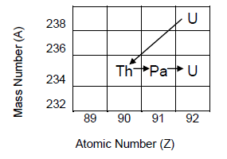
What type of decay particles are emitted during each of the decays listed (and shown in the diagram)? (3 Marks)

a) From Uranium-238 to Thorium-234 | Alpha OR Beta
b) From Thorium-234 to Protactinium-234 | Alpha OR Beta
c) From Protactinium-234 to Uranium-234 | Alpha OR Beta

